data driven testing

Login Functionality Automation Project

pooja dhondkar (batch code:-11266)

2024

## Introduction

The login functionality is a critical component of most web applications, serving as the gateway to access secure user-specific features and data. Ensuring the reliability, security, and efficiency of the login process is essential for maintaining user trust and protecting sensitive information. Manual testing of login functionality can be time-consuming and prone to human error, which is why automating this process is highly beneficial.

## Objectives

This project aims to automate the testing of the login functionality of a web application using Selenium WebDriver with Java. The primary goals are:

Automate Login Functionality: Develop automated tests that can repeatedly verify the login process with different sets of user credentials.

* Ensure Reliability and Consistency: Provide consistent test results to ensure the login functionality works correctly under various conditions.
* Reduce Manual Testing Effort: Minimize the time and effort required for manual testing by using automated tests, allowing testers to focus on more complex test scenarios.

## Existing System

In the existing system, the login functionality of the web application is tested manually. This process involves testers manually entering various sets of user credentials into the login form to verify if the login process works correctly. Manual testing can be time-consuming, prone to errors, and is not efficient for validating multiple test scenarios. Automating this process can significantly improve testing efficiency and accuracy.

**1.4 Tools and Technologies**

* Selenium WebDriver
* Java
* TestNG
* Maven
* IDE (e.g., IntelliJ IDEA, Eclipse)

## Screenshots

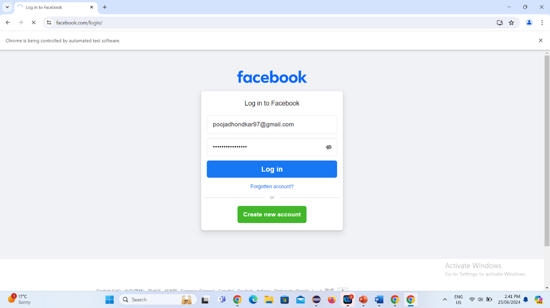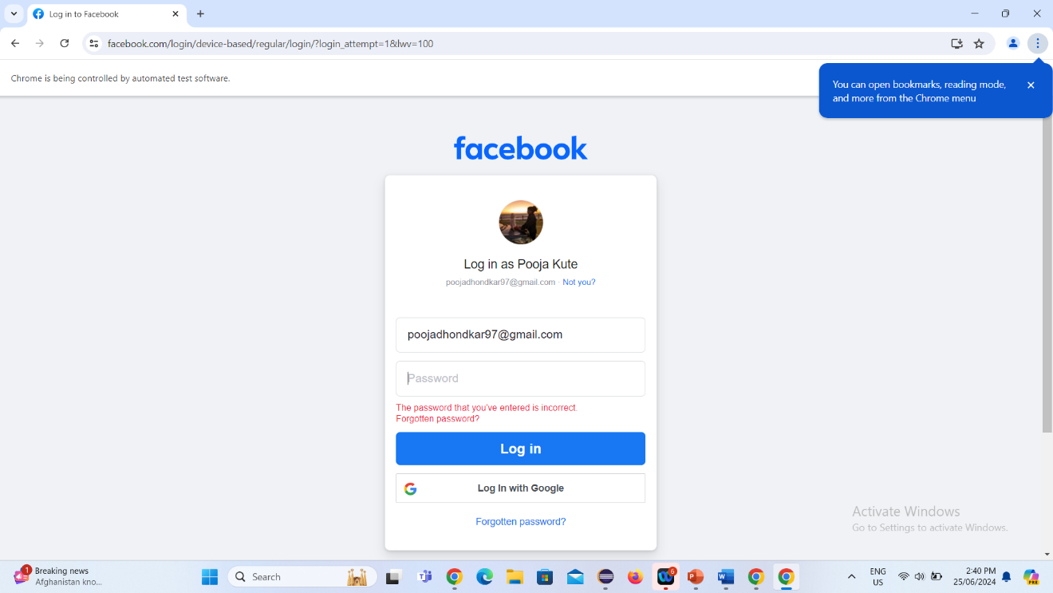

## Conclusion

Automating the login functionality testing helps ensure that the login process is reliable, secure, and efficient. By leveraging Selenium WebDriver with Java and adopting best practices like the Page Object Model and data-driven testing, this project aims to deliver robust automated tests that can be easily maintained and extended. This approach not only improves testing efficiency but also enhances the overall quality of the web application.